(Insert Logo Here)
2014 Sales Compensation Plan
Overview
(Describe the company’s goals for the year and, more specifically, how the sales team should contribute towards their accomplishment. Describe key attributes to the go-to-market model and any initiatives to improve it. Basically, this section is your opportunity to set the stage for the upcoming sales period.)
Metrics
The following metrics are incorporated into the sales compensation plan:
- Metric A
  - Explanation of what Metric A means and how it is determined
- Metric B
  - Explanation of what Metric B means and how it is determined
Commission Payment Exceptions
Conditions that could call for exceptions or reductions to commission payments are as follows:
- Contingencies – Any purchase orders with contingencies that disallow revenue recognition will not be counted until the contingency is released and revenue can be recognized
- Shipments – Any order that does not ship before a given ending period due to last minute notice or lack of proper forecasting in the CRM system will not be counted until the order ships.
- Discounting – Any discounts extended to (customers/partners) must be approved by the CEO or President prior to the receipt of a purchase order reflecting the discounts.
- Side Letters – Absolutely no side letters communicating company commitments or promises are allowed. All information about a particular order must be contained on the purchase order. Violation is possible cause for termination.
- Cash Incentives – Our employees should never be involved in cash incentives to our partners or end customers in exchange for placing an order. Violation will result in immediate termination.
Compensation Plan Mechanics
Base Salary: 60% of your total “on target” compensation amount to be paid in the regular company payroll cycles.
Sales Commission: 40% of your total “on target” compensation amount to be paid within 30 days following the end of each sales period.
Sales Period: Quarterly
Minimum Achievement for Sales Commission: 50% of the quota for the sales period
Method for Calculating Sales Commission: Straight line based on % quota attainment and starting at the Minimum Achievement threshold. See payout example below.
Quota:
- Q1 2014: $150,000 USD
- Q2 2014: $200,000 USD
- Q3 2014: $250,000 USD
- Q4 2014: $250,000 USD

Payout Example
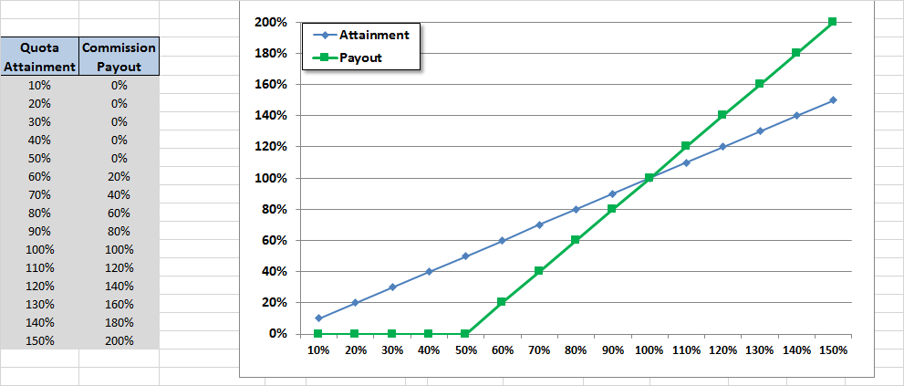

Foreign Corrupt Practices Act Covenant

You must always remain in compliance with the Foreign Corrupt Practices Act of 1977 (FCPA). Neither you or the other sales team members you work with should ever:

use company funds for any unlawful contribution, gift, entertainment or other unlawful expense relating to political activity or to influence official action;

make any direct or indirect unlawful payment to any foreign or domestic government official or employee from company funds;

make any bribe, rebate, payoff, influence payment, kickback or other unlawful payment; or

fail to disclose fully any contribution or payment made by you (or made by any person acting on your behalf of which you are aware) that violates the FCPA.
Failure to comply with this Covenant will be cause for immediate termination of employment.

This Sales Compensation is Signed and Agreed by:

______________________________________
Name

______________________________________
Signature Date

